**Distributed Systems**

**Assignment-10**

Naga Tharun Makkena

SE20UCSE105

Problem 1: Chat Server Implementation.

Output:

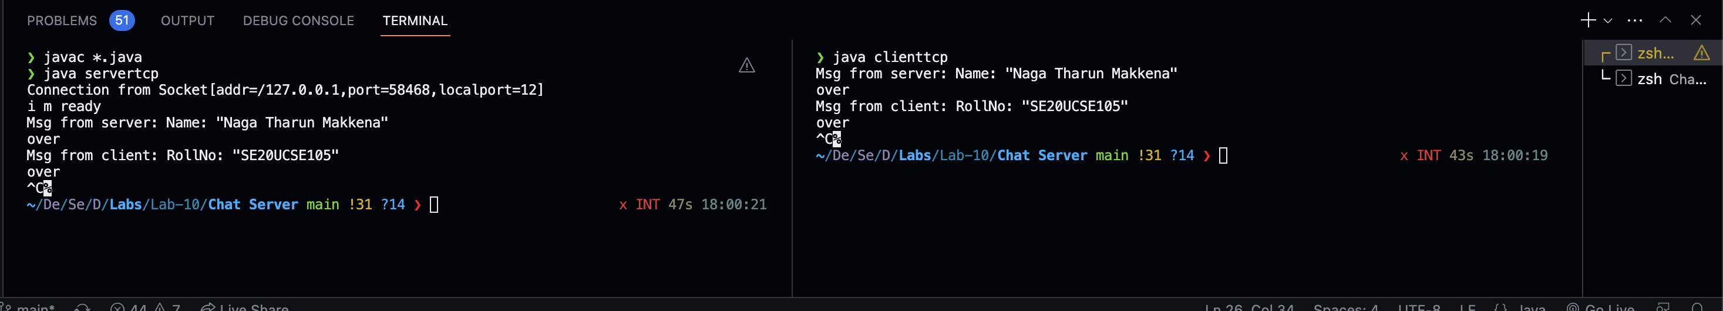



Problem 2: Implementing Publish/Subscribe Paradigm using Web Services, ESB and JMS.

Output:

